SIMATS ENGINEERING (SAVEETHA SCHOOL OF ENGINEERING)
Department of Computer Science and Engineering
ASSESSMENT TOOL 1 – Coding Challenge Task

Course Code: | CSA06 | Course Title: | Design and Analysis of Algorithms
CO Assessed: | CO4: Articulation (BL4, BL5) | Assessment: | Assessment Tool 1 – Coding Challenge Task
Weightage: | 40% of CIA | Total Marks: | 100
CO4 Statement: | Solve optimization problems using dynamic programming and greedy strategies.
Student Name: | PRAVEEN KUMAR | Reg. No.: | 192324287
Section / Batch: | Slot C | Date: | 22.08.2026
Instructions to Students
- Answer the following question. Total Marks: 100.
- Carefully analyze the given questions.
- Write clear code for the given problem.
- Analyze the Time complexity and Space complexity of your code using dynamic programming and greedy strategies

Question Type | Focus Area | Questions
Coding Challenge Task | Focus on Code and analyze optimization problems using dynamic programming and greedy strategies | Q1

SECTION A – Coding Challenge Task
Each job has a deadline and a profit, and only one job can be scheduled at a time. The objective is to schedule the jobs such that the total profit is maximized while ensuring that each selected job is completed before its deadline. Conflicts must be avoided, and the jobs should be scheduled in an optimal order. Use a Greedy Strategy to determine the best job schedule.

Code of Conduct
I CH.Bhavya Sri/12411249 (Name / Reg No) certify that this submission is my original work and that I have adhered to the guidelines specified for this assessment. I understand that any violation of academic integrity rules will result in disciplinary action.
Signature of the Student: CH.Bhavya Sri

RUBRICS FOR CALCULATION
Coding Challenge Task

Criteria | Weightage | Level 4 (Exemplary) | Level 3 (Proficient) | Level 2 (Developing) | Level 1 (Beginning)
Problem Understanding | 20% | Clearly understands problem constraints, edge cases, and  competitive requirements | Understands problem with minor gaps in constraints | Partial understanding; misses key constraints | Misinterprets problem or constraints
Algorithm | 25% | Selects optimal algorithm with best time and space complexity for  competitive constraints | Uses efficient algorithm with minor scope for improvement | Uses basic/inefficient approach | No clear algorithmic approach
Code Implementation | 20% | Writes correct, efficient, and clean code that passes all constraints | Code works with minor errors or inefficiencies | Partially correct code; fails for some cases | Code does not execute or gives incorrect results
Competitive Performance | 20% | Solves problem within time limits and  handles large inputs effectively | Solves within acceptable time with minor delays | Struggles with time limits or larger inputs | Unable to solve within time constraints
Test Case Handling | 15% | Handles all test cases including edge and hidden cases | Handles most test cases | Misses important edge cases | Fails on multiple test cases

Marks Evaluation:
Criteria | Wt. | Level 4 – Exemplary | Level 3 – Proficient | Level 2 – Developing | Level 1 – Beginning
Problem Understanding | 20%
Algorithm | 25%
Code Implementation | 20%
Competitive Performance | 20%
Test Case Handling | 15%
Total Marks (100):

Faculty In-charge | Course Coordinator | Head of Department
Name: | Name: | Name:
Signature: | Signature: | Signature:
Date: | Date: | Date:

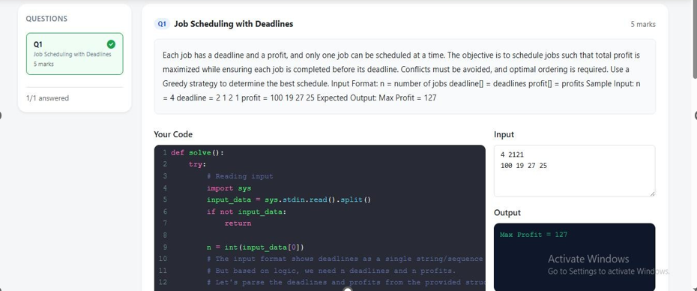
EXPLAINATION
Job Scheduling with Deadlines is an optimization problem solved using the Greedy Method. In this problem, every job has a deadline and a profit, and each job requires one unit of time to complete. The main objective is to select and schedule the jobs in such a way that the maximum possible profit is obtained while making sure that every selected job is completed before its deadline. To solve the problem, we first sort all the jobs according to their profits in descending order. Then, starting with the job having the highest profit, we try to place it in the latest available time slot before its deadline. This helps to keep earlier slots available for other jobs. In the given example, J1 has the highest profit of 100 and deadline 2, so it is placed in the second slot. J3 has a profit of 27 and deadline 2, so it is placed in the first slot. The other jobs cannot be selected because all available slots are occupied. Thus, the selected jobs are J3 and J1, and the total maximum profit is 27 + 100 = 127. This method is called greedy because it always makes the locally best choice by selecting the job with the highest profit at each step.

